UI-Events Onkeydown

Design a web page using onkeydown event in javascript as shown in the screenshot.

Hints : onkeydown Event use onkeydown function and get the value using event.keyCode and convert it to string and display.

Sample Screenshot 1 :  
  
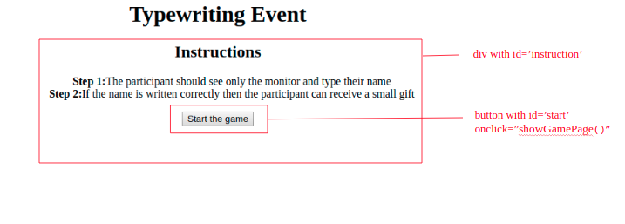  
  
Sample Screenshot 2 :  
  
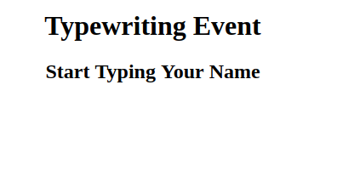  
  
Sample Screenshot 3 :  
  
After the onkeydown event, the keys should be displayed like this.  
  
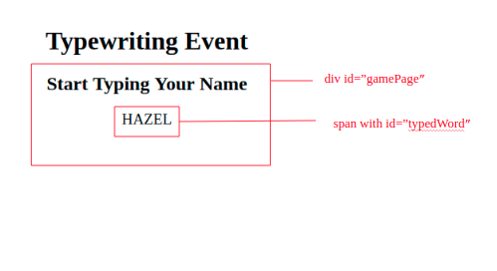  
  
Constraints :  
  
The values should be given for the mentioned fields.  
Use the ids and the values as given in the screenshot.  
The showGamePage() function should be present and document.onkeydown should be inside the function and get the keys using event.keyCode.  
The resultant should be appended to the span tag and all the letters should be in ‘Upper Case'.  
  
On clicking the button the showGamePage() function should be invoked and it should go to the game page.  
In the function use document.onkeydown to get the values and append to the innerHTML of the span tag with id result.  
  
Note :  
  
Content of the page should be present as shown in the screenshot.